**NAME:MUHAMMAD SHURAIM**

**ROLL NO:SU92-BSSEM-S24-071**

**LAB 1**

#include <iostream>

using namespace std;

int main() {

int num = 25;

int* ptr = &num;

cout << "Initial State:" << endl;

cout << "Number: " << num << endl;

cout << "Memory Address: " << ptr << endl;

cout << "Pointer Value: " << *ptr << endl;

*ptr = 75;

cout << "\nAfter Modification:" << endl;

cout << "Updated Number: " << num << endl;

cout << "Memory Address (unchanged): " << ptr << endl;

cout << "Pointer New Value: " << *ptr << endl;

return 0;

}

OUTPUT

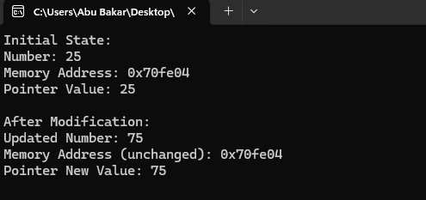

**EXPLANATION**

* Declares an integer variable num and initializes it with 25.
* Declares a pointer ptr that stores the address of num.
* Prints the value of num, the memory address stored in ptr, and the value at that address (*ptr)
* Updates num to 75 using the pointer.
* Shows that num is updated while the memory address remains the same.